N190302 1

**DATA SCIENCE WITH**

**PYTHON**

**STUDENT NAME: DASARI GANGADHAR**

**ID NUMBER: N190302**

**CLASS:** **CSE-03**

DEPARTMENT OF COMPUTER SCIENCE AND ENGINERING

RGUKT-NUZ-AP E2-SEMISTER-II, AY-2022-23

DASARI GANGADHAR Data Science with Python Lab

N190302 2

**Table of Contents :**

|  |  |  |  |  |
| --- | --- | --- | --- | --- |
| **Assign** | **Assignment Name** | |  | **Page Number** |
| **ment** |  |  |  |  |
| **No** |  |  |  |  |
| **1** | **Python Basics** |  |  | **3-5** |
| **2** | **Python Data Structures** | |  | **6-11** |
| **3** | **Python** | **programming** | | **12-16** |
|  | **fundamentals** |  |  |  |
| **4** | **Working with data in python** | | | **17-21** |
| **5** | **Working Numpy Arrays** | |  | **22-25** |
| **6** | **Importing** | **datasets** | **and** | **26-31** |
|  | **Cleaning and** | **preparing** | **the** |  |
|  | **Data** |  |  |  |
| **7** | **Model Development** | |  | **32-36** |
| **8** | **Model Evalution** | |  | **37-39** |
| **9** | **Introduction** | **to visualization** | | **40-41** |
|  | **tools** |  |  |  |
| **10** | **Basic visualization tools** | |  | **42-44** |
| **11** | **Specialized visualization tolls** | | | **45-46** |
| **12** | **Advanced Visualization tools** | | | **47-49** |

DASARI GANGADHAR Data Science with Python Lab

N190302 3

**LAB-01**

**AIM :** a) Python Basics: Your first program, Types Expressions and Variables String Operations

**Code:**

print("hello world")

color="green"

print(type(color))

a=3

print(a,type(a))

b=-3.5

print(b,type(b))

c=2+3j

print(type(c))

d,e,f=2,3,-4

print(f)

print(e)

print(d)

h=j=k="RAJA"

print(h,j,k)

id1='How are you?'

print(id1[1:7])

x=0b11

print(type(x))

val=None

print(val)

**#python string**

id1="Mariya babu"

print(id1[1])

#negative indexing

print(id1[-3])

DASARI GANGADHAR Data Science with Python Lab

N190302 4

#id1[3]=q

#multiline strings

string="""mariya babu is the roommate of durgaprasa

Hari is friend of mariya"""

print(string)

#python string operation

id2=" is the roommate of Durgaprasad"

print(id1+id2)

id3="babu"

id4="babu"

print(id3==id4)

id3="babu"

id4="babu1"

print(id3==id4)

#iterton

gr='welcome'

for letter in gr:

print(letter)

gr='welcome'

for letter in gr:

print(gr)

print(len(gr))

#membership

print("a" in gr)

print("a" not in gr)

print(gr.upper())

print(gr.lower())

print(gr.startswith("h"))

id='name'

name='Gangadhar'

print(f'my {id} is {name}')

#escape sequence

ex="he said,\"what's is there?\""

print(ex)

DASARI GANGADHAR Data Science with Python Lab

N190302 5

**output:**

hello world

<class 'str'>

3 <class 'int'>

-3.5 <class 'float'>

<class 'complex'>

-4

3

2

RAJA RAJA RAJA

ow are

<class 'int'>

None

a

a

mariya babu is the roommate of durgaprasa

Hari is friend of mariya

Mariya babu is the roommate of Durgaprasad

True

False

w

e

l

c

o

m

e

welcome

welcome

welcome

welcome

welcome

welcome

welcome

7

False

True

WELCOME

welcome

False

my name is Gangadhar

he said,"what's is there?"

DASARI GANGADHAR Data Science with Python Lab

N190302 6

**LAB-02**

**AIM :** Python Data Structures: Lists and Tuples Sets,and Dictionaries

**CODE**

**""" list,tuple,dic,set"""**

a=[2,'a','aba','aaa']

print(a)

num=(1,5,3)

print(num)

b={'a':3,'ba':456,'a':4}

print(b)

c={1,4,3,2,5,}

print(c)

d={2,'a','aba','aaa'}

print(d)

lan=["telugu","tamil","kannada"]

print(lan[2])

print(type(lan))

e={2,2,2,3}

print(e)

a=True

print(a)

b=False

print(b)

#list

a=[4,6,7]

print(a)

print(a[0])

print(a[-3])

print(a[0:2])

#append

a.append(2)

print(a)

#extend

DASARI GANGADHAR Data Science with Python Lab

N190302 7

b=[8,9,7]

a.extend(b)

print(a)

a[0]=0

print(a)

#del

del b[1]

print(b)

a.remove(0)

a.sort()

print(a)

a.reverse()

print(a)

a.pop(2)

print(a)

#checking

print(1 in a)

print(len(a))

#list comprehension

c=[]

for x in range(1,6):

c.append(x*x)

print(c)

**#tuple**

print("tuples")

a=(3,4,5)

print(a)

b="hello",

print(type(b))

c=("hello")

print(type(c))

#tuple accessing

print(a[-1])

print(a[1])

print(a[0:2])

DASARI GANGADHAR Data Science with Python Lab

N190302 8

#tuple methods

d=(6,5,7,7,7,8,4,9,0)

print(d.count(7))

print(d.index(6))

#iteration

for x in d:

print(x)

print(7 in d)

**#sets**

a={3,5,6,7,8,9,4,5,6}

b={10,20,30,40}

print("set")

print(a)

print(type(a))

a.add(10)

print(a)

#min

print(min(a))

#max

print(max(a))

#len

print(len(a))

#all

print(all(a))

#any

print(any(a))

#enumerate

print(enumerate(a))

#sum

print(sum(a))

DASARI GANGADHAR Data Science with Python Lab

N190302 9

#sorted

print(sorted(a))

#union

print(a|b)

print(a.union(b))

#intersection

print(a&b)

print(a.intersection(b))

#symmetric difference

print(a^b)

#equal

print(a==b)

**#dictonary**

dic={1:"a",2:"b",3:"c",4:"d",5:"e"}

print(dic)

print(type(dic))

#adding

dic[6]="f"

print(dic)

#changing

dic[3]="C"

print(dic)

#accessing

print(dic[3])

#remove

del dic[6]

print(dic)

DASARI GANGADHAR Data Science with Python Lab

N190302 10

* sorted sorted(c) print(dic)

#membership

print(1 in dic)

print(4 not in dic)

**output:**

[2, 'a', 'aba', 'aaa']

(1, 5, 3)

{'a': 4, 'ba': 456}

{1, 2, 3, 4, 5}

{2, 'aba', 'a', 'aaa'}

kannada

<class 'list'>

{2, 3}

True

False

[4, 6, 7]

4

4

[4, 6]

[4, 6, 7, 2]

[4, 6, 7, 2, 8, 9, 7]

[0, 6, 7, 2, 8, 9, 7]

[8, 7]

[2, 6, 7, 7, 8, 9]

[9, 8, 7, 7, 6, 2]

[9, 8, 7, 6, 2]

False

5

[1, 4, 9, 16, 25]

tuples

(3, 4, 5)

<class 'tuple'>

<class 'str'>

5

4

(3, 4)

3

0

DASARI GANGADHAR Data Science with Python Lab

N190302 11

6

5

7

7

7

8

4

9

0

True

set

{3, 4, 5, 6, 7, 8, 9}

<class 'set'>

{3, 4, 5, 6, 7, 8, 9, 10}

3

10

8

True

True

<enumerate object at 0x000001803DC96E80>

52

[3, 4, 5, 6, 7, 8, 9, 10]

{3, 4, 5, 6, 7, 8, 9, 10, 40, 20, 30}

{3, 4, 5, 6, 7, 8, 9, 10, 40, 20, 30}

{10}

{10}

{3, 4, 5, 6, 7, 40, 8, 9, 20, 30}

False

{1: 'a', 2: 'b', 3: 'c', 4: 'd', 5: 'e'}

<class 'dict'>

{1: 'a', 2: 'b', 3: 'c', 4: 'd', 5: 'e', 6: 'f'}

{1: 'a', 2: 'b', 3: 'C', 4: 'd', 5: 'e', 6: 'f'}

C

{1: 'a', 2: 'b', 3: 'C', 4: 'd', 5: 'e'}

{1: 'a', 2: 'b', 3: 'C', 4: 'd', 5: 'e'}

True

False

DASARI GANGADHAR Data Science with Python Lab

N190302 12

**LAB-03**

**AIM:** Python Programming Fundamentals: Conditions and Branching Loops, Functions,Objects and Classes

**Code:**

a=30

b=60

c=40

**#if else**

if(a<b):

print(a)

else:

print(b)

**#if elif else**

if(a>b):

print("greater",a)

elif(b>c):

print("greater",b)

else:

print("greater",c)

**#nested if**

d=60

if(a>b):

if(a>c):

if(a>d):

print("greater",a)

elif(b>a):

if(b>c):

if(b>d):

print(" greater",b)

elif(c>a):

if(c>b):

if(c>d):

print("greatest",c)

DASARI GANGADHAR Data Science with Python Lab

N190302 13

else:

print("greater",c)

#shorthand if

print("a is less than b") if(a<b) else print("b is less")

**output:**

30

greater 60

a is less than b

**# FOR LOOP**

print("for loop in python")

name="DASARI GANGADHAR"

print(name)

print("printing each character in python")

for i in name:

print(i)

print("Printing numbers from 1 to 21 with difference of 2 using for loop")

for i in range (1,22,2):

print(i,end=" ")

print()

**#while loop**

print("while loop in python:")

i=1

while i<=4:

print("dasari", end="")

j=1

while j<=3:

print("gangadhar", end="")

j+=1

i+=1

print()

outputs:

for loop in python

DASARI GANGADHAR

printing each character in python

D

A

DASARI GANGADHAR Data Science with Python Lab

N190302 14

S

A

R

I

G

A

N

G

A

D

H

A

R

Printing numbers from 1 to 21 with difference of 2 using for loop 13579111315171921 while loop in python:

dasarigangadhargangadhargangadhar

dasarigangadhargangadhargangadhar

dasarigangadhargangadhargangadhar

dasarigangadhargangadhargangadhar

**Classes and objects**

**Code**:

class animal:

def speak(self):

print("i am speaking")

class dog(animal):

def bark(self):

print("i am barking")

d=dog()

d.bark()

d.speak()

**Output:**

i am barking

i am speaking

**//Built in class objects**

**Code:**

class student:

def __init__(self,name,id,age) :

self.name=name

self.id=id

DASARI GANGADHAR Data Science with Python Lab

N190302 15

self.age=age

s=student("mani",45,18)

print(getattr(s,'name'))

setattr(s,"age",19)

print(getattr(s,"age"))

print(hasattr(s,'id'))

delattr(s,'age')

**Output:**

mani

19

True

**INHERITANCE:**

Code:

class animal:

def speak(self):

print("i am speaking")

class dog(animal):

def bark(self):

print("i am barking")

class dogchild(dog):

def eat(self):

print("i am eating")

d=dogchild()

d.eat()

d.bark()

d.speak()

**Output:**

i am eating

i am barking

i am speaking

**//Multiple inheritance**

Code:

class fam:

def speak(self):

print("hi i am mani")

class ram(fam):

def eat(self):

print("i am eating")

class raj(ram):

def sleep(self):

print("i am sleeping ")

DASARI GANGADHAR Data Science with Python Lab

N190302 16

d=raj()

d.sleep()

d.eat()

d.speak()

**Output:**

i am sleeping

i am eating

hi i am mani

**//Abstarct classes**

Code:

from abc import ABC,abstractmethod

class car(ABC):

def mileage(self):

pass

class maruthi(car):

def mileage(self):

print("the mileage is:30kmph")

class suzuki(car):

def mileage(self):

print("the mileage is:25kmph")

class bazaz(car):

def mileage(self):

print("the mileage is:35kmph")

m=maruthi()

m.mileage()

s=suzuki()

s.mileage()

b=bazaz()

b.mileage()

**Output:**

the mileage is:30kmph

the mileage is:25kmph

the mileage is:35kmph

base class: 123

DASARI GANGADHAR Data Science with Python Lab

N190302 17

**LAB-04**

**AIM:** Working with Data in Python: Reading files with open, Writing files with open,Loading data with Pandas, Working with and Saving data with Pandas

**CODE:**

import pandas as pd

import numpy as np

print(pd.__version__)

b=[1,2,3,4]

c=pd.Series(b)

print(c)

b=['s','d']

c=pd.Series(b[-1])

print(c)

d=np.array(['a','b','c','d'])

s=pd.Series(d)

r=pd.DataFrame(d)

print(s)

print(r)

print(len(s))

s=pd.Series(d,index=[101,103,103,104])

j=pd.Series(d,index=["x","y","z","w"])

print(s)

print(j)

dataset={'icecreams':['vanila','strawberry','badam','pista'],

'rating':[4.5,3.8,4.2,4.6]

}

ds=pd.DataFrame(dataset)

print(ds)

ds=pd.Series(dataset)

print(ds)

**Output:**

2.0.1

0 1

DASARI GANGADHAR Data Science with Python Lab

N190302 18

1. 2
2. 3
3. 4 dtype: int64
4. d dtype: object
5. a
6. b
7. c
8. d dtype: object

0

1. a
2. b
3. c
4. d
5. a
6. b
7. c
8. d

dtype: object x a

y b z c w d dtype: object

icecreams rating

|  |  |  |
| --- | --- | --- |
| 0 | vanila | 4.5 |
| 1 | strawberry | 3.8 |
| 2 | badam | 4.2 |
| 3 | pista | 4.6 |

icecreams [vanila, strawberry, badam, pista]

rating [4.5, 3.8, 4.2, 4.6]

dtype: object

**Attribute of series**

import pandas as pd

import numpy as np

ds=np.array(['a','b','c','d'])

d=pd.Series(ds)

print(d)

DASARI GANGADHAR Data Science with Python Lab

N190302 19

d=pd.Series(ds ,index=[101,102,103,"e"])

print(d)

print(d[103])

ds1={'d1':100,'d2':200,'d3':300}

d=pd.Series(ds1)

print(d)

j=pd.Series(ds1,index=['d1','d2'])

print(j)

print(j.name)

print(j.values)

print(j.size)

print(d.shape)

print(d.ndim)

print(d.nbytes)

print(d.memory_usage)

print(j.empty)

j.name='raj'

print(j.name)

**output:**

1. a
2. b
3. c
4. d

dtype: object

1. a
2. b
3. c

e d dtype: object c

d1 100

d2 200

d3 300 dtype: int64 d1 100 d2 200 dtype: int64 None

[100 200]

(3,)

<bound method Series.memory_usage of d1 100 d2 200

DASARI GANGADHAR Data Science with Python Lab

N190302 20

d3 300

dtype: int64>

False

raj

**Multiplication of series :**

import pandas as pd

import numpy as np

ds1=np.array([1,1,2,3,4])

d1=pd.Series(ds1)

ds2=np.array([2,2,3,4,5])

d2=pd.Series(ds2)

a=d1.add(d2)

print(a)

b=d1.sub(d2)

print(b)

c=d1.mul(d2)

print(c)

d=d1.multiply(4)

print(d)

e=d1.div(d2)

print(e)

f=d2.mod(d1)

print(f)

g=d2.pow(3)

print(g)

h=d2.le(d1)

print(h)

i=d2.gt(d1)

print(i)

j=d2.equals(d1)

print(j)

**output:**

1. 3
2. 3
3. 5
4. 7
5. 9 dtype: int32
6. -1
7. -1
8. -1

DASARI GANGADHAR Data Science with Python Lab

N190302 21

1. -1
2. -1 dtype: int32
3. 2
4. 2
5. 6
6. 12
7. 20 dtype: int32
8. 4
9. 4
10. 8
11. 12
12. 16 dtype: int32
13. 0.500000
14. 0.500000
15. 0.666667
16. 0.750000
17. 0.800000 dtype: float64
18. 0
19. 0
20. 1
21. 1
22. 1 dtype: int32
23. 8
24. 8
25. 27
26. 64
27. 125 dtype: int32
28. False
29. False
30. False
31. False
32. False dtype: bool
33. True
34. True
35. True
36. True
37. True dtype: bool False

DASARI GANGADHAR Data Science with Python Lab

N190302 22

**LAB-05**

**Aim:** Working with Numpy Arrays: Numpy 1d Arrays, Numpy 2d Arrays **Code:**

import numpy as np

from numpy import random

a=np.array([1,2,3,4])

print(a)

b=np.array([[1,2,3,4,5],[6,7,8,9,0]])

print(b)

c=np.array([[[1,2,3],[4,5,6],[7,0,9]]])

print(c)

d=np.array(32)

print(d)

print(a.ndim)

print(b.ndim)

print(c.ndim)

print(d.ndim)

e=np.array([1,2,3,4] ,ndmin=5)

print(e)

f=np.array([5,6],ndmin=3)

print(f)

print(f.ndim)

print(b[1,2])

#slicing

print(a[0:2])

print(a[2:])

print(a[:3])

print(a[-4:-2])

print(a[1:4:2])

print(a[1:4:3])

print(a[::1])

print(b[1,0:3:2])

g=np.array([1,2,3,4],dtype='S')

print(g)

DASARI GANGADHAR Data Science with Python Lab

N190302 23

print(b[1,0::3])

print(type(g))

print(g.dtype)

i=np.array([1.1,2.2,3.3,4.4])

print(i)

j=i.astype('i')

print(j)

print(i)

a=([1,3,4],[5,6,7])

b=np.asarray(a,order='f')

print(b)

for i in np.nditer(b):

print(i)

a=np.zeros((5,2 ),dtype=int)

print(a)

b=np.full([2,3],56 ,dtype=float)

print(b)

c=np.ones(([4,2]),dtype=int)

print(c)

x=random.randint(10000)

print(x)

for i in range(1,5):

x=random.randint(10)

print(x)

d=np.eye(5,3 ,dtype=int, k=-1)

print(d)

a=np.eye(3,3, dtype=int)

print(a)

b=np.asarray(a,order='f')

for i in np.nditer(b):

print(i)

#captcha

x=random.randint(10000)

print(x)

c=int(input('enter the capctha'))

while(c!=x):

print("invalid captcha")

c=int(input('enter'))

DASARI GANGADHAR Data Science with Python Lab

N190302 24

print("valid")

c=random.rand(3,2)

print(c)

d=random.ranf([3,2])

print(d)

**output:**

[1234]

[[12345]

[67890]]

[[[1 2 3]

[456]

[7 0 9]]]

32

1

2

3

0

[[[[[1 2 3 4]]]]]

[[[5 6]]]

3

8

[1 2]

[3 4]

[123]

[1 2]

[2 4]

[2]

[1234]

[6 8]

[b'1' b'2' b'3' b'4']

[6 9]

<class 'numpy.ndarray'>

|S1

[1.1 2.2 3.3 4.4]

[1234]

[1.1 2.2 3.3 4.4]

[[1 3 4]

[5 6 7]]

1

5

3

6

4

DASARI GANGADHAR Data Science with Python Lab

N190302 25

7

[[0 0]

[0 0]

[0 0]

[0 0]

[0 0]]

[[56. 56. 56.]

[56. 56. 56.]]

[[1 1]

[1 1]

[1 1]

[1 1]]

5425

7

2

4

3

[[0 0 0]

[100]

[010]

[001]

[0 0 0]]

[[1 0 0]

[010]

[0 0 1]]

1

0

0

0

1

0

0

0

1

7479

enter the capctha7479

valid

[[0.14702871 0.94097438]

[0.80805663 0.52615084]

[0.45495018 0.4452953 ]]

[[0.99567496 0.61726301]

[0.44050543 0.35901677]

[0.69665999 0.3356309 ]]

DASARI GANGADHAR Data Science with Python Lab

N190302 26

**LAB-06**

**Aim:** Importing Datasets: Learning Objectives, Understanding the Domain, Understandingthe Dataset, Python package for data science, Importing and Exporting Data in Python, BasicInsights from Datasets

Cleaning and Preparing the Data: Identify and Handle Missing Values, Data Formatting, Data Normalization Sets, Binning, Indicator variables

**Code:**

**Importing datasets and preparing the data**

import pandas as pd

df=pd.read_csv(r'C:\Users\DASARI GANGADHAR\Desktop\DSP\data1.csv')

d=pd.DataFrame(df)

print(d)

d=df.loc[4]

print(d)

d=df.loc[2:3]

print(d)

print(df.loc[1,"Name"])

print(df.loc[0:4,["Name","marks"]])

print(df.loc[4:8,"Name":"marks"])

"""ILOC"""

print(df.iloc[3])

print(df.iloc[3:8])

print(df.iloc[3:8,1])

print(df.iloc[5:9,1:3])

print(df.iloc[[2,4,6,7]])

output:

Unnamed: 0 Name id marks

0 1 Dasari R1254 14

1. 2 Gangadhar R1255 14
2. 3Sree R1256 13
3. 4Raj R1257 12
4. 5Ram R1258 15
5. 6Roja R1259 13

|  |  |  |  |  |
| --- | --- | --- | --- | --- |
| 6 | 7 | Rahul R1260 | 14 | |
| 7 | 8 | Ramya R1261 11 | |
| 8 | 9 | Siri NaN | 12 | |

DASARI GANGADHAR Data Science with Python Lab

|  |  |  |  |
| --- | --- | --- | --- |
| N190302 | | 27 | |
| 9 | 10 | Lava R1263 10 | |
| Unnamed: 0 | | 5 | |
| Name |  | Ram | |
| id | R1258 | |
| marks |  | 15 | |

Name: 4, dtype: object

Unnamed: 0 Name id marks

1. 3 Sree R1256 13
2. 4 Raj R1257 12 Gangadhar

Name marks

|  |  |  |
| --- | --- | --- |
| 0 | Dasari | 14 |
| 1 | Gangadhar | 14 |
| 2 | Sree | 13 |
| 3 | Raj | 12 |
| 4 | Ram | 15 |

|  |  |  |  |
| --- | --- | --- | --- |
|  | Name | id marks | |
| 4 | Ram R1258 | | 15 | |
| 5 | Roja R1259 | | 13 | |
| 6 | Rahul R1260 | | 14 | |
| 7 | Ramya R1261 11 | | |
| 8 | Siri | NaN | 12 | |
| Unnamed: 0 | | | 4 | |
| Name | | Raj |  | |
| id |  | R1257 |  | |
| marks | | 12 |  | |

|  |  |  |  |  |
| --- | --- | --- | --- | --- |
| Name: 3, dtype: object | | |  | |
|  | Unnamed: 0 Name id marks | | |
| 3 | 4 | Raj R1257 | 12 | |
| 4 | 5 | Ram R1258 | 15 | |

1. 6 Roja R1259 13
2. 7 Rahul R1260 14
3. 8 Ramya R1261 11
4. Raj
5. Ram
6. Roja
7. Rahul
8. Ramya

Name: Name, dtype: object

Name id

1. Roja R1259
2. Rahul R1260
3. Ramya R1261
4. Siri NaN

|  |  |  |
| --- | --- | --- |
|  | Unnamed: 0 Name | id marks |
| 2 | 3 Sree R1256 | 13 |

DASARI GANGADHAR Data Science with Python Lab

|  |  |  |
| --- | --- | --- |
| N190302 | | 28 |
| 4 | 5 Ram R1258 | 15 |

1. 7 Rahul R1260 14
2. 8 Ramya R1261 11

**Data cleaning**

**dropna()**

import pandas as pd

import numpy as np

df=pd.read_csv(r'C:\Users\DASARI GANGADHAR\Desktop\DSP\data1.csv')

print(df)

d=df.dropna()

print(d)

print(df)

print(df.loc[:,["marks","Name"]].dropna())

d=df.dropna(inplace=True)

print(d)

print(df)

**output:**

Unnamed: 0 Name id marks

0 1 Dasari R1254 14

1. 2 Gangadhar R1255 14
2. 3Sree R1256 13
3. 4Raj R1257 12
4. 5Ram R1258 15
5. 6Roja R1259 13

|  |  |  |  |  |  |  |
| --- | --- | --- | --- | --- | --- | --- |
| 6 | 7 | Rahul R1260 | | | 14 | |
| 7 | 8 | Ramya R1261 | | | 11 | |
| 8 | 9 | Siri | NaN | 12 | |
| 9 | 10 | Lava R1263 | | | 10 | |
|  | Unnamed: 0 | | Name | id | marks | |
| 0 | 1 | Dasari R1254 | |  | 14 | |

1. 2 Gangadhar R1255 14
2. 3Sree R1256 13
3. 4Raj R1257 12
4. 5Ram R1258 15
5. 6Roja R1259 13

|  |  |  |  |  |
| --- | --- | --- | --- | --- |
| 6 | 7 | Rahul R1260 | | 14 |
| 7 | 8 | Ramya R1261 | | 11 |
| 9 | 10 |  | Lava R1263 | 10 |
|  | Unnamed: 0 | | Name id | marks |
| 0 | 1 | Dasari R1254 | | 14 |
| 1 | 2 | Gangadhar R1255 | | 14 |

DASARI GANGADHAR Data Science with Python Lab

|  |  |  |  |  |  |  |  |
| --- | --- | --- | --- | --- | --- | --- | --- |
| N190302 | | |  |  |  | 29 | |
| 2 |  | 3 | Sree R1256 | |  | 13 | |
| 3 |  | 4 | Raj R1257 | |  | 12 | |
| 4 |  | 5 | Ram R1258 | | | 15 | |
| 5 |  | 6 | Roja R1259 | |  | 13 | |
| 6 |  | 7 | Rahul R1260 | | | 14 | |
| 7 |  | 8 | Ramya R1261 | | | 11 | |
| 8 |  | 9 | Siri | NaN | 12 | |
| 9 |  | 10 | Lava R1263 | | | 10 | |
|  | marks | | Name |  |  |  | |
| 0 | 14 |  | Dasari |  |  |  | |
| 1 | 14 | Gangadhar | |  |  |  | |
| 2 | 13 |  | Sree |  |  |  | |
| 3 | 12 |  | Raj |  |  |  | |
| 4 | 15 |  | Ram |  |  |  | |
| 5 | 13 |  | Roja |  |  |  | |
| 6 | 14 |  | Rahul |  |  |  | |
| 7 | 11 |  | Ramya |  |  |  | |
| 8 | 12 |  | Siri |  |  |  | |
| 9 | 10 |  | Lava |  |  |  | |
| None | |  |  |  |  |  | |
|  | Unnamed: 0 | | | Name | id marks | |
| 0 |  | 1 | Dasari R1254 | |  | 14 | |

1. 2 Gangadhar R1255 14
2. 3Sree R1256 13
3. 4Raj R1257 12
4. 5Ram R1258 15
5. 6Roja R1259 13

|  |  |  |  |
| --- | --- | --- | --- |
| 6 | 7 | Rahul R1260 | 14 |
| 7 | 8 | Ramya R1261 | 11 |
| 9 | 10 | Lava R1263 | 10 |

**fillna()**

import pandas as pd

df=pd.read_excel(r"C:\Users\DASARI GANGADHAR\Desktop\DSP\data2.xlsx")

print(df)

d=df.fillna("missing")

print(d)

df.fillna("missing",inplace=True)

print(df)

**output:**

name gender age weight

0 John M 48.0 128.6

DASARI GANGADHAR Data Science with Python Lab

|  |  |  |  |  |  |  |  |
| --- | --- | --- | --- | --- | --- | --- | --- |
| N190302 | |  |  |  |  | 30 | |
| 1 | Peter | NaN 58.0 | | 158.3 | | |
| 2 | Liz | F NaN | | 115.5 | | |
| 3 | Joe | M 28.0 | | 170.1 | | |
|  | name | gender | age weight | | | |
| 0 | John | M | 48.0 | |  | 128.6 | |
| 1 | Peter | missing | 58.0 | | | 158.3 | |
| 2 | Liz | F missing | | |  | 115.5 | |
| 3 | Joe | M | 28.0 | | 170.1 | |
|  | name | gender | age weight | | | |
| 0 | John | M | 48.0 | |  | 128.6 | |
| 1 | Peter | missing | 58.0 | | | 158.3 | |
| 2 | Liz | F missing | | |  | 115.5 | |
| 3 | Joe | M | 28.0 | | 170.1 | |

**isnull()**

import pandas as pd

import numpy as np

df=pd.read_excel(r"data2.xlsx")

print(df)

print(df.isnull())

print(df.notnull())

d=df.replace(to_replace="Liz",value="Loe")

print(d)

di=df.interpolate(method="linear",limit_direction="forward")

print(di)

**output:**

Unnamed: 0 Name id marks

0 1 Dasari R1254 14

1. 2 Gangadhar R1255 14
2. 3Sree R1256 13
3. 4Raj R1257 12
4. 5Ram R1258 15
5. 6Roja R1259 13

|  |  |  |  |  |  |  |
| --- | --- | --- | --- | --- | --- | --- |
| 6 | 7 | Rahul R1260 | | | 14 | |
| 7 | 8 | Ramya R1261 | | | 11 | |
| 8 | 9 | Siri | NaN | 12 | |
| 9 | 10 | Lava R1263 | | | 10 | |
|  | Unnamed: 0 | | Name | id | marks | |
| 0 | 1 | Dasari R1254 | |  | 14 | |

1. 2 Gangadhar R1255 14
2. 3Sree R1256 13
3. 4Raj R1257 12

DASARI GANGADHAR Data Science with Python Lab

|  |  |  |  |  |
| --- | --- | --- | --- | --- |
| N190302 | |  |  | 31 |
| 4 | 5 |  | Ram R1258 | 15 |
| 5 | 6 |  | Roja R1259 | 13 |
| 6 | 7 | Rahul R1260 | | 14 |
| 7 | 8 | Ramya R1261 | | 11 |
| 9 | 10 |  | Lava R1263 | 10 |
|  | Unnamed: 0 | | Name id | marks |
| 0 | 1 | Dasari R1254 | | 14 |

1. 2 Gangadhar R1255 14
2. 3Sree R1256 13
3. 4Raj R1257 12
4. 5Ram R1258 15
5. 6Roja R1259 13

|  |  |  |  |  |  |  |  |  |  |
| --- | --- | --- | --- | --- | --- | --- | --- | --- | --- |
| 6 |  | 7 |  | Rahul R1260 | | |  | 14 | |
| 7 |  | 8 |  | Ramya R1261 | | |  | 11 | |
| 8 |  | 9 |  | Siri | NaN | 12 | | |
| 9 |  | 10 | | Lava R1263 | | |  | 10 | |
|  | marks | |  | Name |  |  |  |  | |
| 0 | 14 |  |  | Dasari |  |  |  |  | |
| 1 | 14 | Gangadhar | | |  |  |  |  | |
| 2 | 13 |  |  | Sree |  |  |  |  | |
| 3 | 12 |  |  | Raj |  |  |  |  | |
| 4 | 15 |  |  | Ram |  |  |  |  | |
| 5 | 13 |  |  | Roja |  |  |  |  | |
| 6 | 14 |  |  | Rahul |  |  |  |  | |
| 7 | 11 |  |  | Ramya |  |  |  |  | |
| 8 | 12 |  |  | Siri |  |  |  |  | |
| 9 | 10 |  |  | Lava |  |  |  |  | |
| None | |  |  |  |  |  |  |  | |
|  | Unnamed: 0 | | | | Name | id | | marks | |
| 0 |  | 1 |  | Dasari R1254 | |  |  | 14 | |
| 1 |  | 2 | Gangadhar R1255 | | | | | 14 | |
| 2 |  | 3 |  | Sree R1256 | |  | 13 | |
| 3 |  | 4 |  | Raj R1257 | |  | 12 | |
| 4 |  | 5 |  | Ram R1258 | | |  | 15 | |
| 5 |  | 6 |  | Roja R1259 | |  |  | 13 | |
| 6 |  | 7 |  | Rahul R1260 | | |  | 14 | |
| 7 |  | 8 |  | Ramya R1261 | | |  | 11 | |
| 9 |  | 10 | | Lava R1263 | | |  | 10 | |

DASARI GANGADHAR Data Science with Python Lab

N190302 32

**LAB-07**

**Aim:** Model Development: Simple and Multiple Linear Regression, Model EvaluationUsingVisualization, Polynomial Regression and Pipelines, R-squared and MSE for In-Sample Evaluation, Prediction and Decision Making

**CODE:** simple linear regression

import numpy as np

import pandas as pd

import matplotlib.pyplot as plt

dataset=pd.read_excel('aw.xlsx')

dataset.head()

dataset.isna().sum()

x=dataset.iloc[:,:1].values

y=dataset.iloc[:,:-1].values

from sklearn.model_selection import train_test_split

x_train,x_test,y_train,y_test=train_test_split(x,y,test_size=0.2,random_state=0)

from sklearn.linear_model import LinearRegression regressor=LinearRegression() regressor.fit(x_train,y_train)

y_pred=regressor.predict(x_test)

plt.scatter(x_train,y_train,color="orange")

plt.plot(x_train,regressor.predict(x_train),color="green")

plt.xlabel('weight')

plt.ylabel('age')

plt.show()

DASARI GANGADHAR Data Science with Python Lab

N190302 33

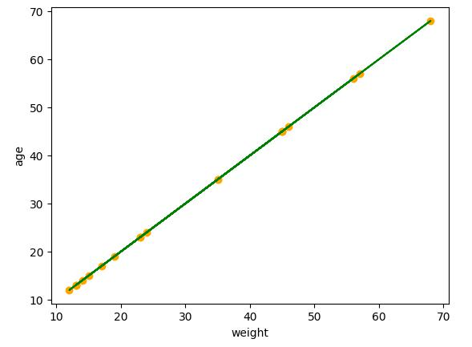

plt.scatter(x_test,y_test,color="orange")

plt.plot(x_test,regressor.predict(x_test),color="green")

plt.xlabel('weight')

plt.ylabel('age')

plt.show()

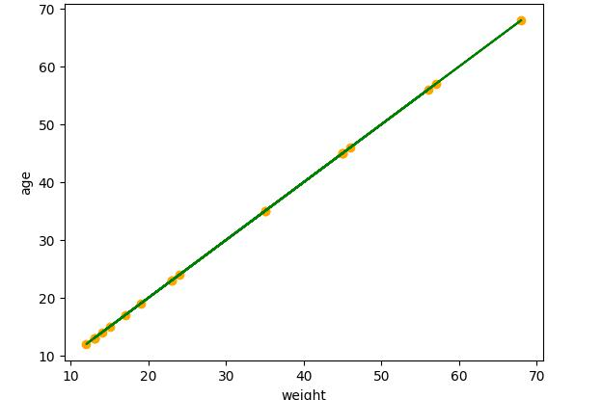

DASARI GANGADHAR Data Science with Python Lab

N190302 34

**Code:**Multiple linear regression

#importing pandas

import pandas as pd

#importing data set

df=pd.read_csv("class1.csv")

#making list of independent variales as x and dependent variable as y

X= df[['Height','Age']]

y = df['Weight']

#to import this sklearn pip install -U scikit-learn from sklearn import linear_model

regr = linear_model.LinearRegression()

regr.fit(X, y)

predictedCO2 = regr.predict([[2300, 1300]])

print(predictedCO2)

print(regr.coef_)

predictedCO2 = regr.predict([[3300, 1300]])

print(predictedCO2)

**CODE:** polynomial regression

import pandas as pd

import numpy as np

import matplotlib.pyplot as plt

df = pd.read_csv('ageweight.csv')

df

df.describe()

X=df.iloc[:,1:2].values

y=df.iloc[:,2].values

from sklearn.linear_model import LinearRegression lin_reg=LinearRegression() lin_reg.fit(X,y)

from sklearn.preprocessing import PolynomialFeatures poly_reg2=PolynomialFeatures(degree=2)

DASARI GANGADHAR Data Science with Python Lab

N190302 35

X_poly=poly_reg2.fit_transform(X)

lin_reg_2=LinearRegression()

lin_reg_2.fit(X_poly,y)

poly_reg3=PolynomialFeatures(degree=3)

X_poly3=poly_reg3.fit_transform(X)

lin_reg_3=LinearRegression()

lin_reg_3.fit(X_poly3,y)

plt.scatter(X,y,color='red')

plt.plot(X,lin_reg.predict(X),color='blue')

plt.title('Truth Or Bluff (Linear Regression)')

plt.xlabel('age')

plt.ylabel('weight')

plt.show()

plt.scatter(X,y,color='red')

plt.plot(X,lin_reg_2.predict(poly_reg2.fit_transform(X)),color='blue')

plt.plot(X,lin_reg_3.predict(poly_reg3.fit_transform(X)),color='green')

plt.title('Truth Or Bluff (Polynomial Linear Regression)')

plt.xlabel('age')

plt.ylabel('weight')

plt.show()

X_grid=np.arange(min(X),max(X),0.1) # This will give us a vector.We will have to convert this into a matrix

X_grid=X_grid.reshape((len(X_grid),1))

plt.scatter(X,y,color='red')

plt.plot(X_grid,lin_reg_3.predict(poly_reg3.fit_transform(X_grid)),color='green')

#plt.plot(X,lin_reg_3.predict(poly_reg3.fit_transform(X)),color='green')

plt.title('Truth Or Bluff (Polynomial Linear Regression)')

plt.xlabel('age')

plt.ylabel('weight')

plt.show()

lin_reg.predict([[6.5]])

lin_reg_2.predict(poly_reg2.fit_transform([[6.5]]))

lin_reg_3.predict(poly_reg3.fit_transform([[6.5]]))

DASARI GANGADHAR Data Science with Python Lab

N190302 36

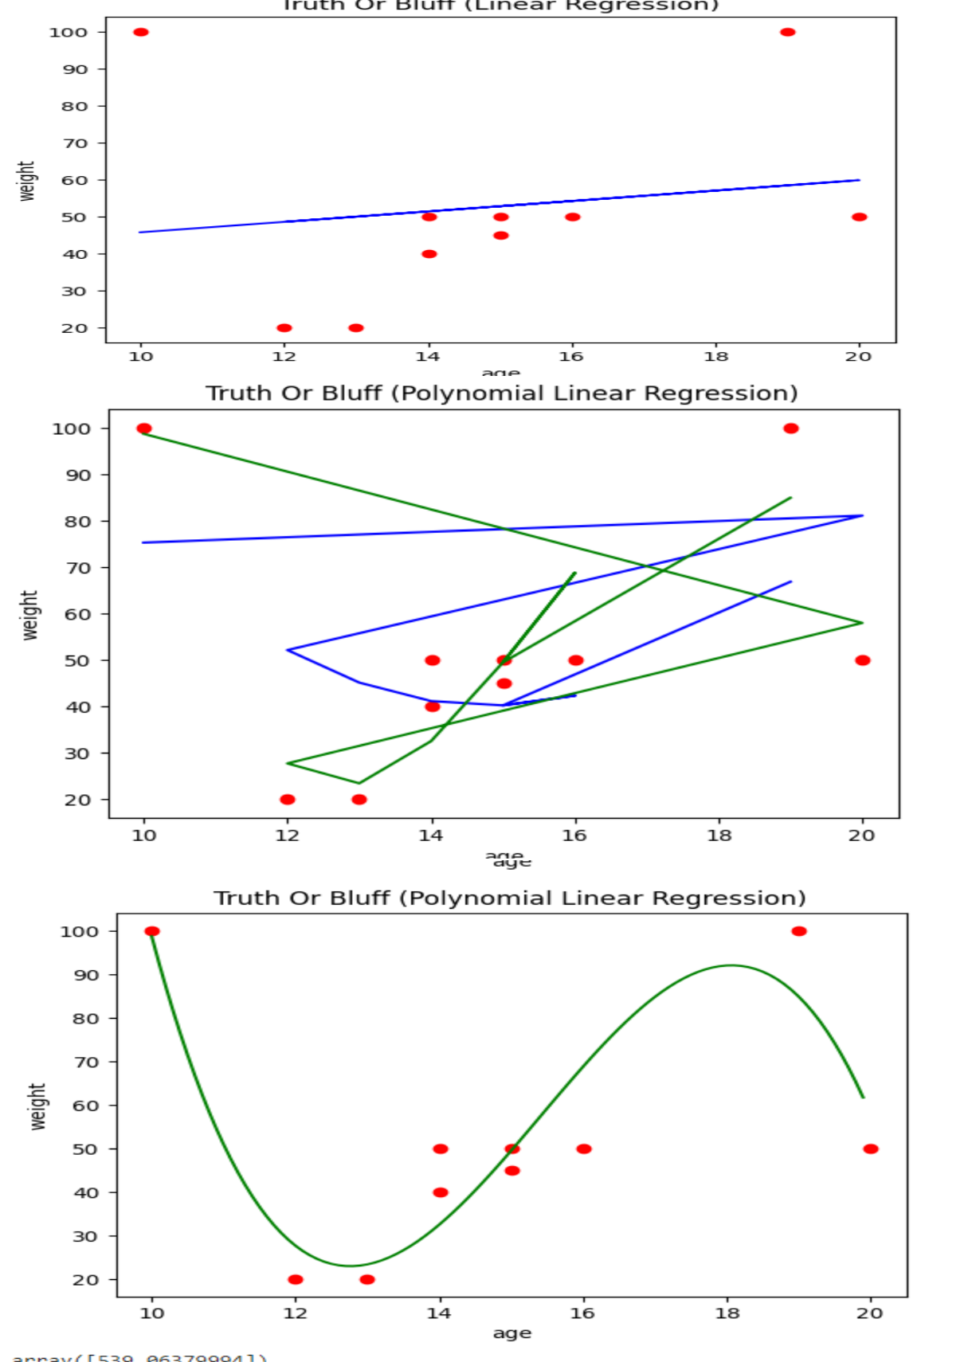

DASARI GANGADHAR Data Science with Python Lab

N190302 37

**LAB-08**

**Aim:** Model Evaluation: Model Evaluation, Over-fitting, Under-fitting and Model Selection,Ridge Regression, Grid Search, Model Refinement

**Code: Ridge regression**

import pandas as pd

import matplotlib.pyplot as plt

from sklearn.model_selection import train_test_split from sklearn.linear_model import Ridge from sklearn import metrics

import numpy as np

df=pd.read_csv("PewDiePie.csv")

#dividing the variables into dependent and independent X=pd.DataFrame(df['Date']) y=pd.DataFrame(df['Subscribers'])

#Split the data into train and test sets

X_train,X_test,y_train,y_test=train_test_split(X,y,test_size=0.2,random_state=1)

#train the algorithm

ridge=Ridge(alpha=1.0)

ridge.fit(X_train,y_train)

#retriving the intercept

print(ridge.intercept_)

#retriving the slope

print(ridge.coef_)

#predecting the test results

y_pred = ridge.predict(X_test)

#evaluting the algorithm

print('Mean Absolute Error:',metrics.mean_absolute_error(y_test,y_pred))

print('Mean Squared Error:',metrics.mean_squared_error(y_test,y_pred))

print('Root Mean Squared Error:',np.sqrt(metrics.mean_squared_error(y_test,y_pred)))

#plot for the train set

plt.scatter(X_train, y_train, color='red') # plotting the observation line

plt.plot(X_train, ridge.predict(X_train), color='blue') # plotting the regression line plt.title("Date vs Subscribers (Training set)") # stating the title of the graph

DASARI GANGADHAR Data Science with Python Lab

N190302 38

plt.xlabel("Date") # adding the name of x-axis plt.ylabel("Subscribers") # adding the name of y-axis plt.show() # specifies end of graph

#plot for the test set

plt.scatter(X_test, y_test, color='red')

plt.plot(X_train, ridge.predict(X_train), color='blue') # plotting the regression line plt.title("Date vs Subscribers (Testing set)") plt.xlabel("Date")

plt.ylabel("Subscribers")

plt.show()

**output:**

[47611.65464541]

[[-605.65189665]]

Mean Absolute Error: 7670.798653106103

Mean Squared Error: 74374253.37775256

Root Mean Squared Error: 8624.05086822617

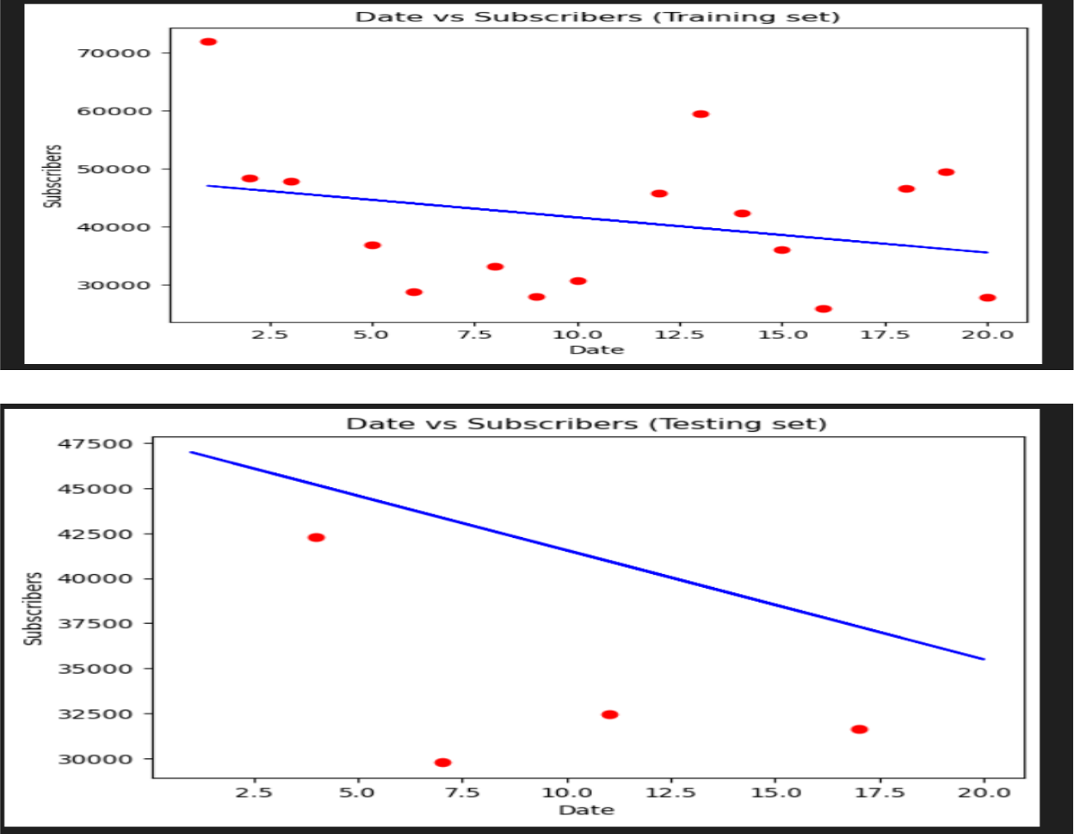

DASARI GANGADHAR Data Science with Python Lab

N190302 39

**Overfitting and underfitting Problem:**

Import numpy as np

Import matplotlib.pypplot as plt

from sklearn.pipeline import Pipeline from sklearn.preprocessing import PolynomialFeatures from sklearn.linear_model import LinearRegression #this allows us to create a random dataset X = np.sort(np.random.rand(100)) #Lets create a true function true_f = lambda X: np.cos(3.5 * np.pi * X)

y = true_f(X) + np.random.randn(100) * 0.1

degrees = [1,15]

plt.figure(figsize=(15, 10))

for i in range(len(degrees)):

ax = plt.subplot(1, len(degrees), i+1)

plt.setp(ax, xticks=(), yticks=()) polynomial_features = PolynomialFeatures(degree=degrees[i], include_bias=False) linear_regression = LinearRegression() pipeline=Pipeline([("polynomial_features",polynomial_features),("linear_regression", linear_regression)])

pipeline.fit(X[:, np.newaxis], y) #Testing

X_test = np.linspace(0, 1, 100)

hat = pipeline.predict(X_test[:, np.newaxis])

plt.plot(X_test, hat,label="Model")

plt.plot(X_test, true_f(X_test), label="True function") plt.scatter(X, y, label="Samples")

plt.xlabel("x") plt.ylabel("y")

plt.xlim((0, 1))

plt.ylim((-2, 2))

plt.legend(loc="best")

plt.title("Degree %d" % degrees[i])

plt.show()

Output:

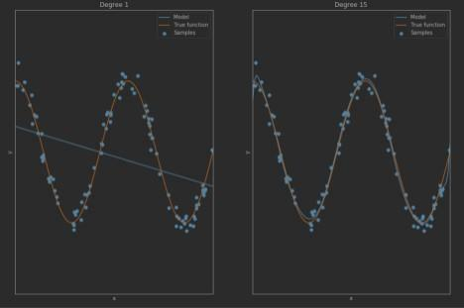

DASARI GANGADHAR Data Science with Python Lab

N190302 40

**LAB-9**

**Aim:**Introduction to Visualization Tools: Introduction to Data Visualization,Introduction to Matplotlib

CODE:

**#scatterplot**

d1=df.head(50)

x_scatter=d1['yearsExperience']

y_scatter=d1['salary']

plt.xlabel('yearsExperience')

plt.ylabel('Salary')

plt.scatter(x_scatter,y_scatter,label="Scatter plot")

plt.legend()

plt.show()

**output:**

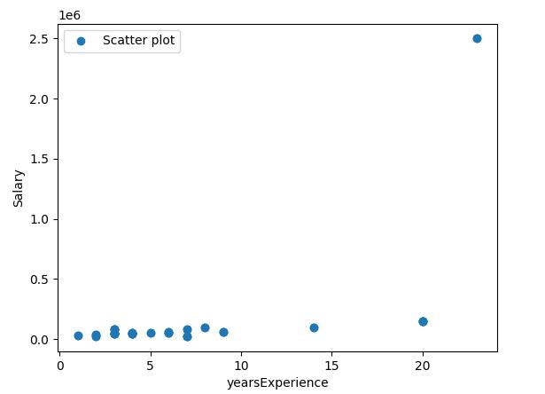

DASARI GANGADHAR Data Science with Python Lab

N190302 41

import matplotlib.pyplot as plt

import numpy as np

x=np.linspace(0,1*np.pi,10000)

y=np.sin(x)

fig, ax=plt.subplots()

ax.plot(x,y)

plt.show()

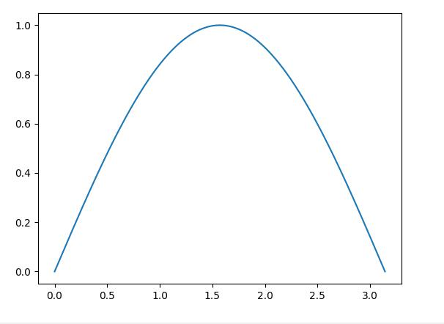

DASARI GANGADHAR Data Science with Python Lab

N190302 42

**LAB-10**

**AIM:**Basic Visualization Tools: Area Plots,Histograms,Bar Charts

import numpy as np

import pandas as pd

import matplotlib.pyplot as plt

df=pd.read_csv(r"C:\Users\DASARI GANGADHAR\Desktop\DSP\salary.csv")

**#line plots**

x=df["yearsExperience"]

y=df["salary"]

plt.xlabel("yearsExperience")

plt.ylabel("salary")

plt.plot(x,y,linestyle="solid",label="Employee data" )

plt.title("yearsExperience vs salary")

plt.grid()

plt.legend()

plt.show()

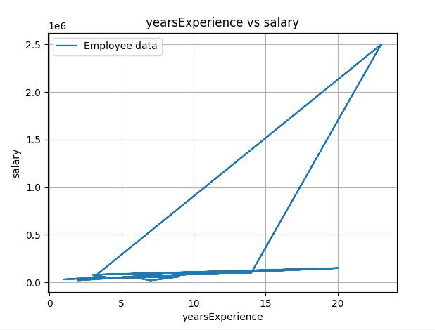

**#areaplots**

d2=df.head()

print(d2['yearsExperience'])

x_area=d2['yearsExperience']

DASARI GANGADHAR Data Science with Python Lab

N190302 43

y_area=d2['salary']

plt.xlabel('yearsExperience')

plt.ylabel('Salary')

plt.fill_between(x_area,y_area,label="Area Plot",color="crimson")

plt.legend()

plt.show()

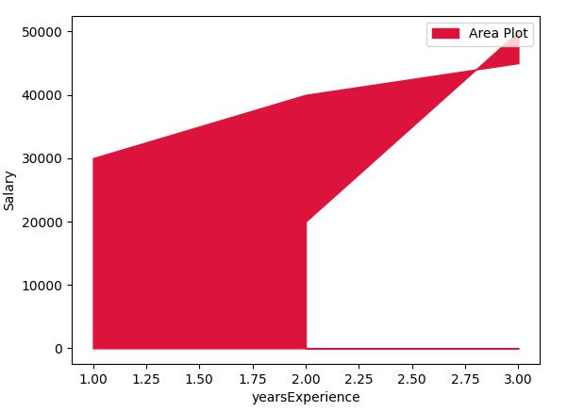

**#Bar plots**

x_bar=df['yearsExperience']

y_bar=df['salary']

plt.bar(x_bar,y_bar,label='yearsExperience',width=0.4,edgecolor="navy")

plt.title('Employee data')

plt.xlabel('yearsExperience')

plt.ylabel('salary')

plt.show()

DASARI GANGADHAR Data Science with Python Lab

N190302 44

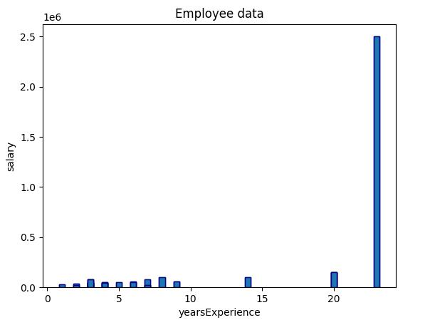

**#histogram**

x_h=df['yearsExperience']

plt.hist(x_h,bins=10)

plt.xlabel('yearsExperience')

plt.show()

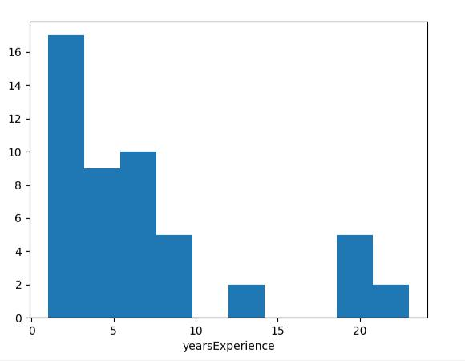

DASARI GANGADHAR Data Science with Python Lab

N190302 45

**LAB-11**

**Aim:** Specialized visualization tools pie charts ,boxplots

**Code:**

**#pie**

dt=df.head()

x_pie=dt['yearsExperience']

y_pie=dt['salary']

plt.axis('equal')

plt.pie(y_pie,labels=x_pie,colors=['pink','lightgreen','grey','crimson','yellow'],shadow=True,autop

ct='%2.1f%%')

plt.legend(title="yearsExperience",loc="best")

plt.show()

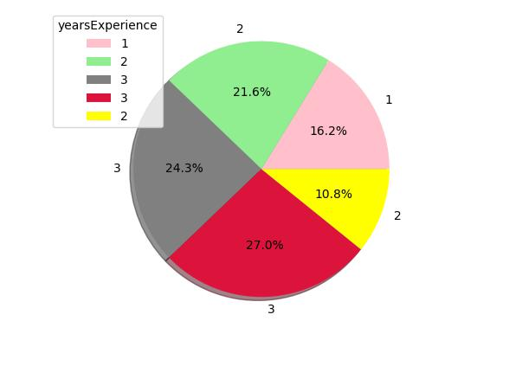

DASARI GANGADHAR Data Science with Python Lab

N190302 46

**#box plot**

import pandas as pd

import matplotlib.pyplot as plt

import numpy as np

data = pd.read_csv("data.csv")

data.head()

x = data.Volume

plt.boxplot(x)

plt.show()

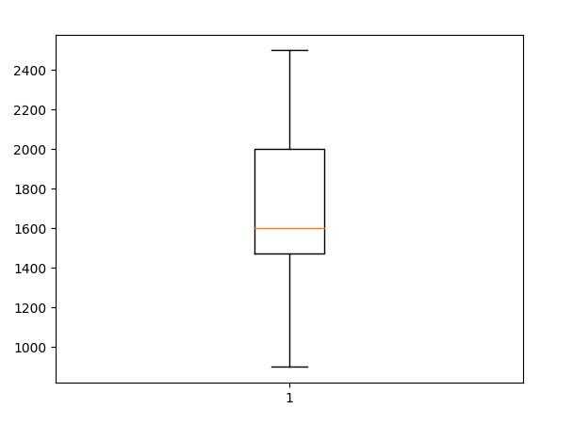

DASARI GANGADHAR Data Science with Python Lab

N190302 47

**LAB-12**

**Aim:**

Advanced Visualization Tools: Waffle Charts, Word Clouds,Seaborn and Regression Plots

**CODE:**

**WAFFLE CHART**

* python program to generate Waffle Chart
* importing all necessary requirements import pandas as pd

import matplotlib.pyplot as plt from pywaffle import Waffle

* creation of a dataframe

data ={'grossary': ['wheat', 'rice','ragi',

'jowar', 'dal'],

'stock': [12, 40, 18, 5, 10]}

df = pd.DataFrame(data)

# To plot the waffle Chart

fig = plt.figure(FigureClass = Waffle,

rows = 5,values = df.stock,

labels = list(df.grossary))

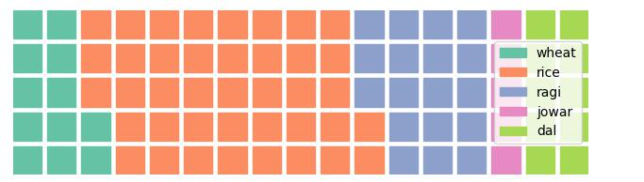

**#word cloud**

#python code for Word cloud

from wordcloud import WordCloud

import matplotlib.pyplot as plt

text="DASARI GANGADHAR n190302"

wc=WordCloud().generate(text)

plt.imshow(wc)

plt.axis("off")

plt.show()

DASARI GANGADHAR Data Science with Python Lab

N190302 48



**#SEABORN**

import numpy as np

import seaborn as sns

sns.set(style="white")

* Generate a random univariate dataset rs = np.random.RandomState(10)

d = rs.normal(size=200)

* Plot a simple histogram and kde sns.histplot(d, kde=True, color="green")

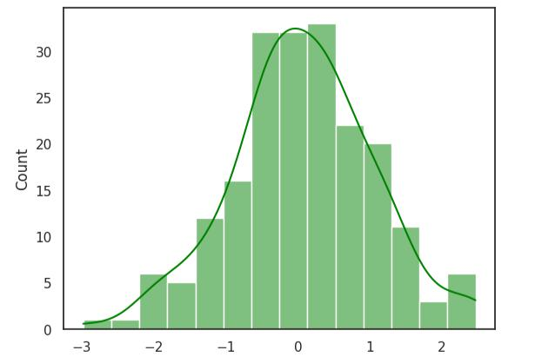

**#maps**

* import the library import folium
* Make an empty map

DASARI GANGADHAR Data Science with Python Lab

N190302 49

m = folium.Map(location=[20,0], tiles="OpenStreetMap", zoom_start=2)

* Import the pandas library import pandas as pd
* Make a data frame with dots to show on the map data = pd.DataFrame({

'lon':[-58, 20.5937, 145, 30.32, -4.03, -73.57, 36.82, -38.5], 'lat':[-34, 78.9629, -38, 59.93, 5.33, 45.52, -1.29, -12.97], 'name':['Buenos Aires', 'norway', 'melbourne', 'St Petersbourg', 'Abidjan', 'Montreal', 'Nairobi', 'Salvador'],

'value':[10, 12, 40, 70, 23, 43, 100, 43] }, dtype=str)

* add marker one by one on the map

for i in range(0,len(data)):

folium.Marker(

location=[data.iloc[i]['lat'], data.iloc[i]['lon']],

popup=data.iloc[i]['name'],

).add_to(m)

* Show the map again

M

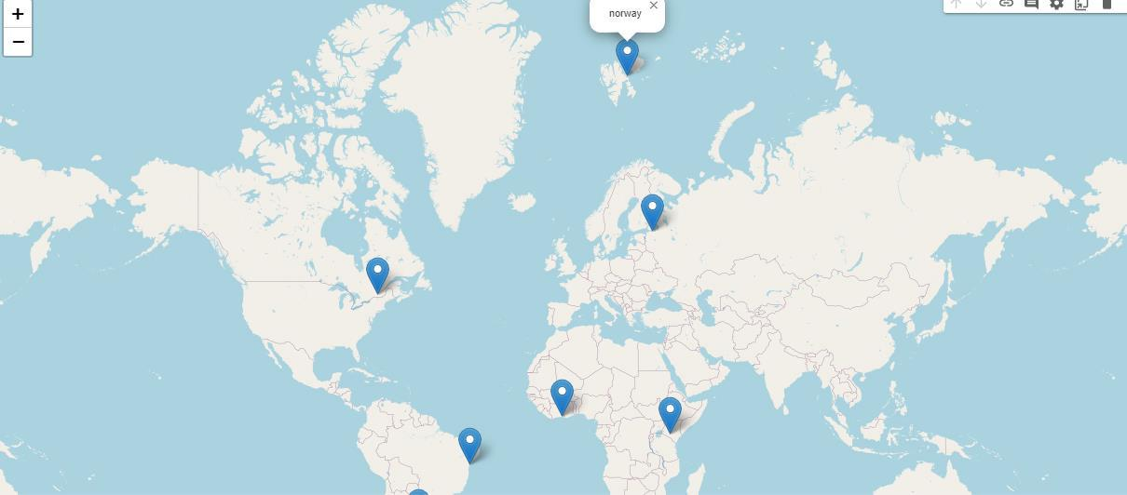

DASARI GANGADHAR Data Science with Python Lab